Communicating with github.com and your computer.

1. To set your computer up, start changing into the directory that you want to hold your git repositories.

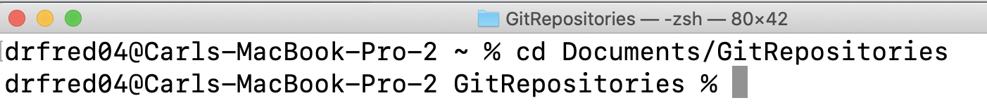

1. Now clone the master branch of the repository that is located on the github.com site. This will only give you the master branch on your computer. This figure shows a list of the GitRepositories folder on my computer before and after I clone the Coffee-Bear-Robot repository from github.com. After cloning I have a new folder “Coffee-Bear-Robor”.

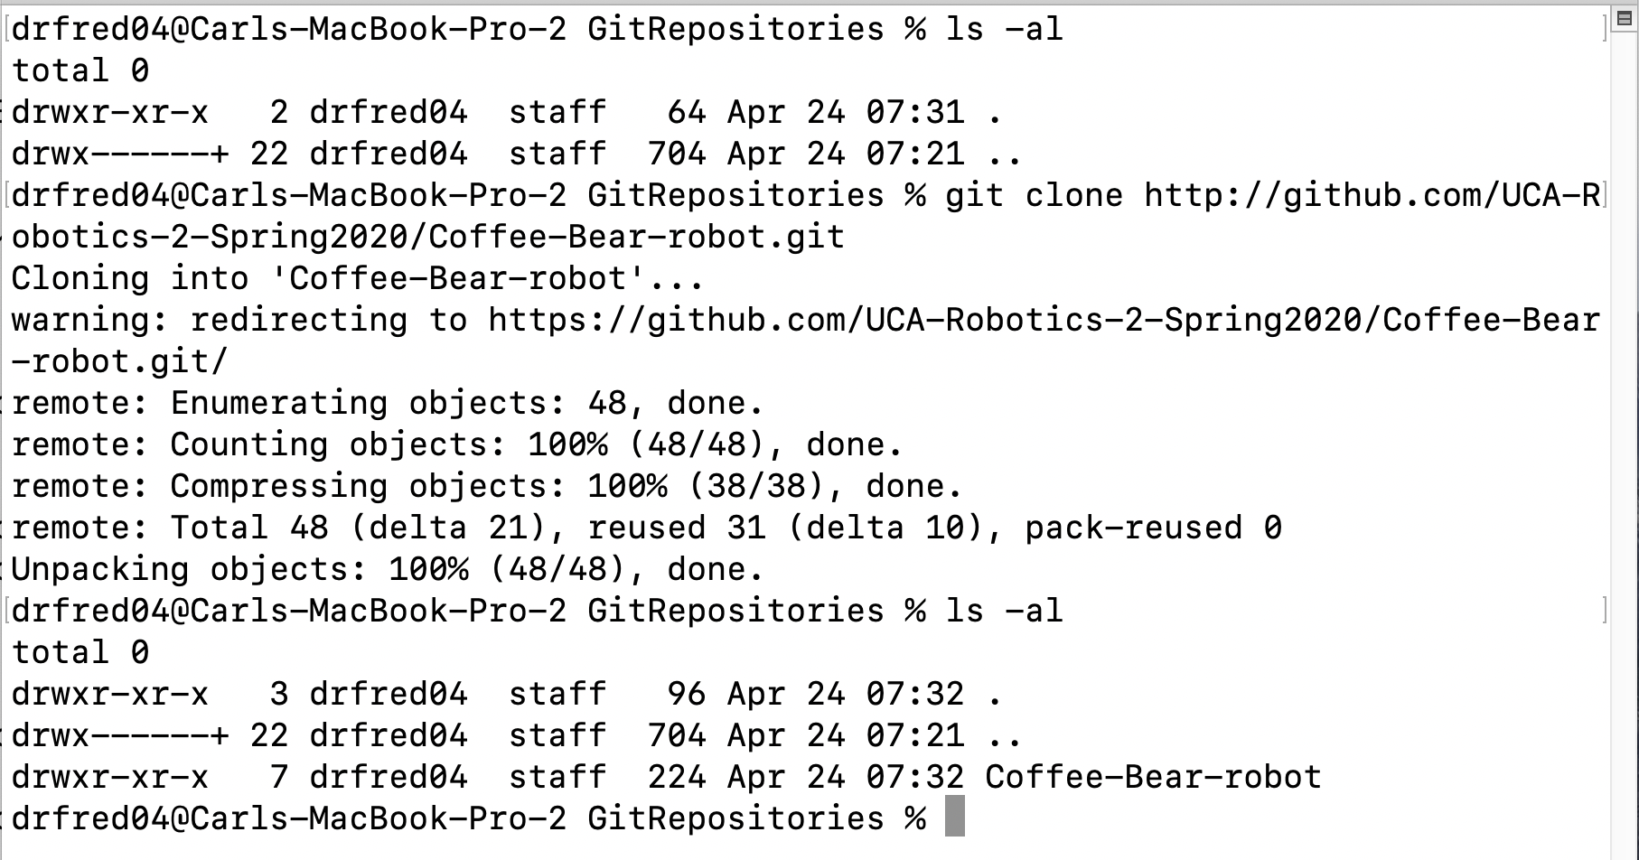

1. Jump into this folder and list all of the branches that are available. There is only one, the “master” branch. If we want to work on a different branch from github.com we will have to create it and then pull that branch down.

*git branch*

This will list all of the branches that are available.

**

*git branch lidar*

This will create a “lidar” branch in your local repository

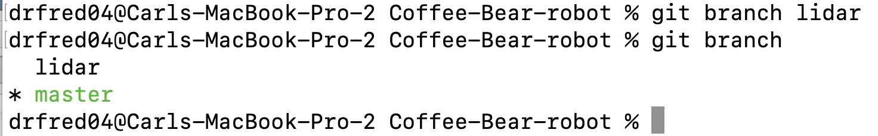

Note that the branch you are working in currently is highlighted (on my computer in green with the asterisks)

*git checkout lidar*

This will set you up to work in the “lidar” branch

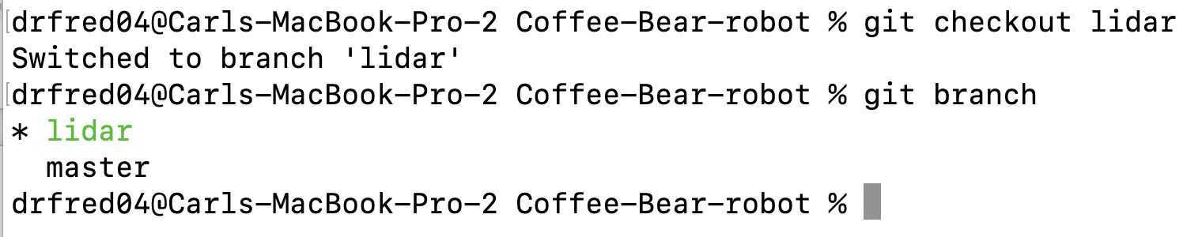

Note the change in the highlighted branch to “lidar”

At this point the *lidar* branch on my computer is the same as the *master* branch. All I have done is add a second tag to what is contained in the *master* branch. Note there is no directory called lidar on my computer.

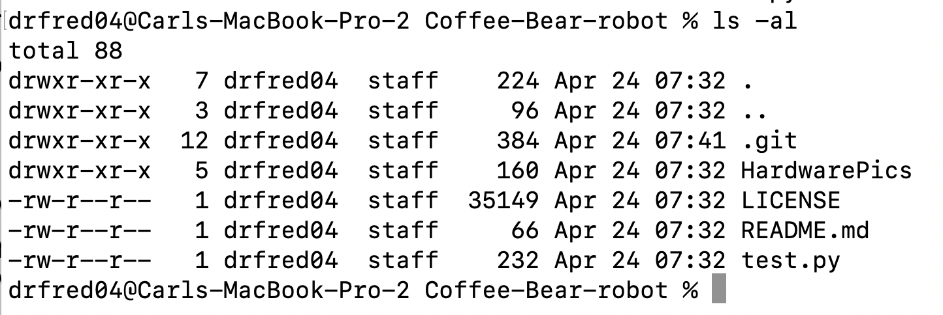

I need to pull the *lidar* branch down form the github.com site.

*git pull origin lidar*

This will pull the state of the lidar branch down from the site. Make sure that you are in the *lidar* branch on your computer or you will pull the branch and put it into your *master* branch.

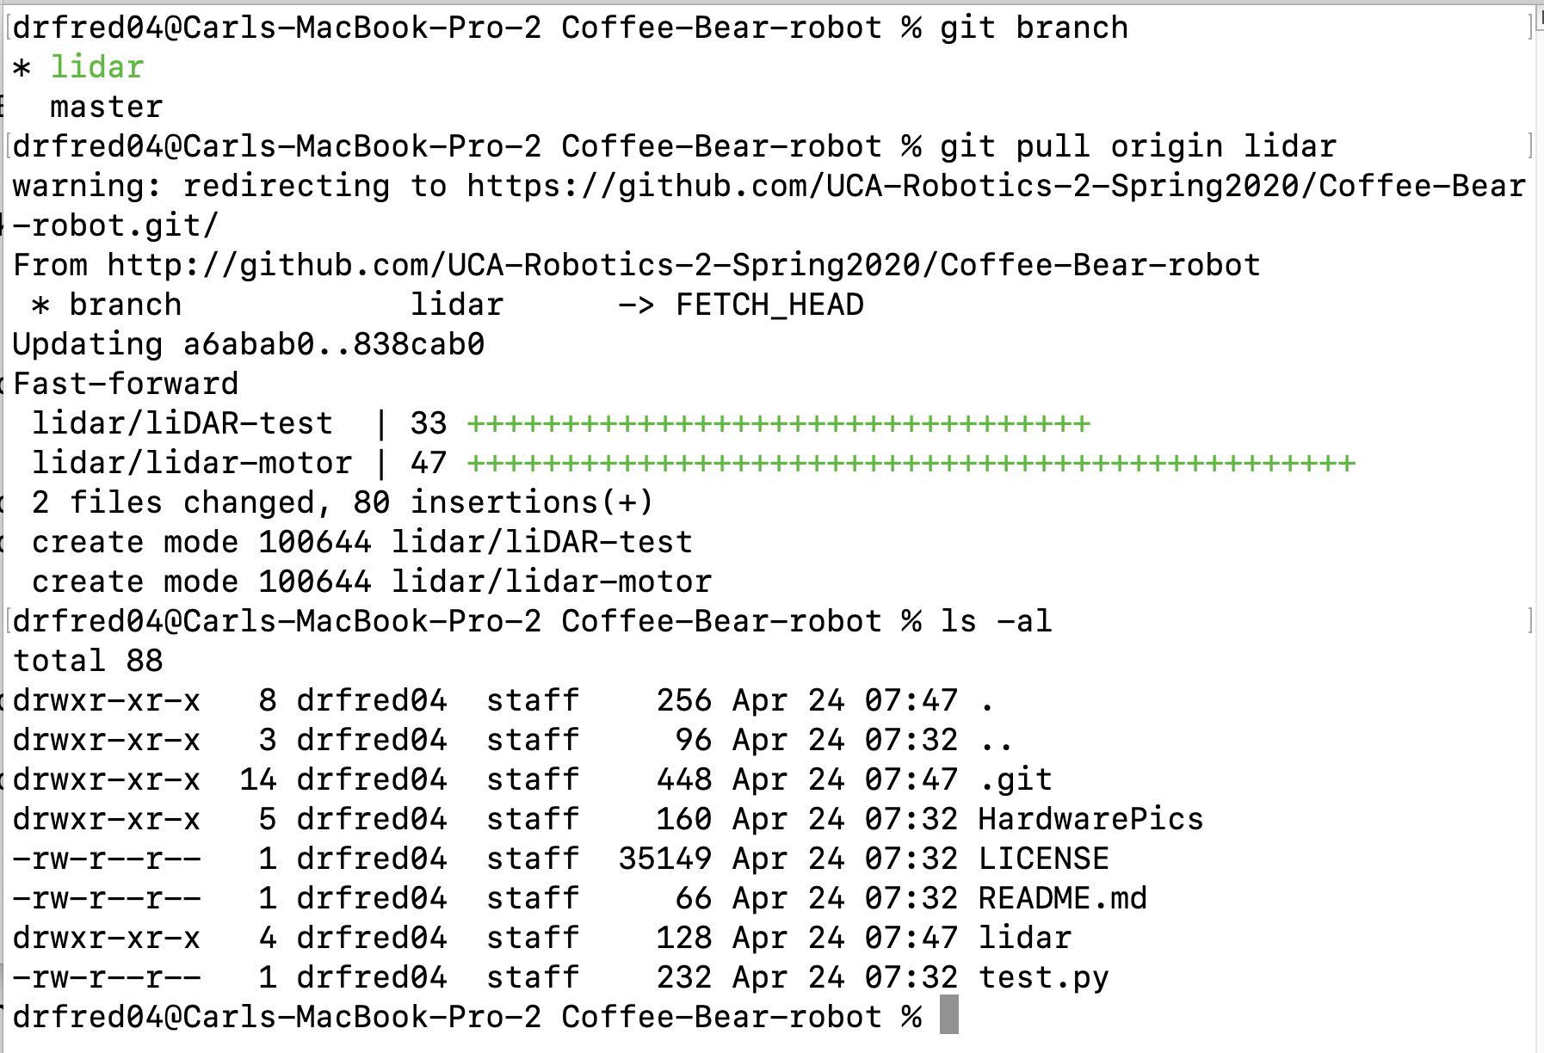

1. You can see that you now have two versions of the project the *lidar* version contains things that have not been moved into the *master* version yet. This allows you to work on a new version of the project while not messing up the old one.

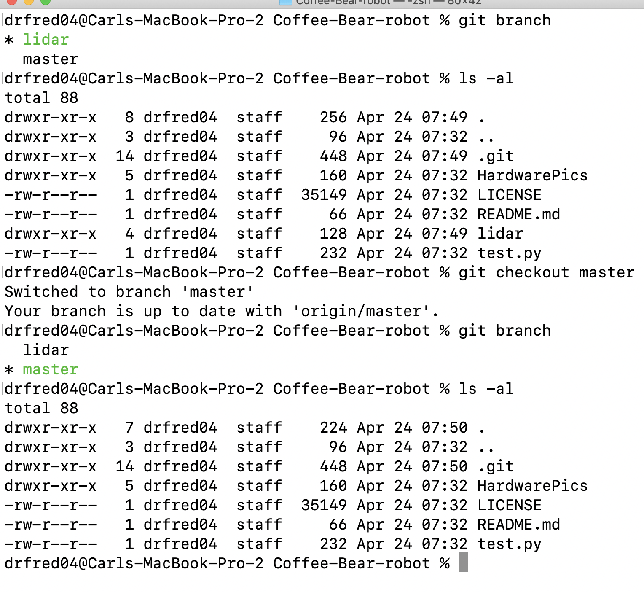

1. Now I want to work on something in a branch locally and then upload it for everyone to see. On the website I have created a branch called *test-branch*. To work in and share my work I will need to
   1. Create the branch on my computer
   2. Switch to that branch on my computer
   3. Pull the branch down from the website
   4. Do something, anything that makes a change in the branch
   5. Add that change to the branch
   6. Commit the change to the branch
   7. Push the branch back up to the website

a)

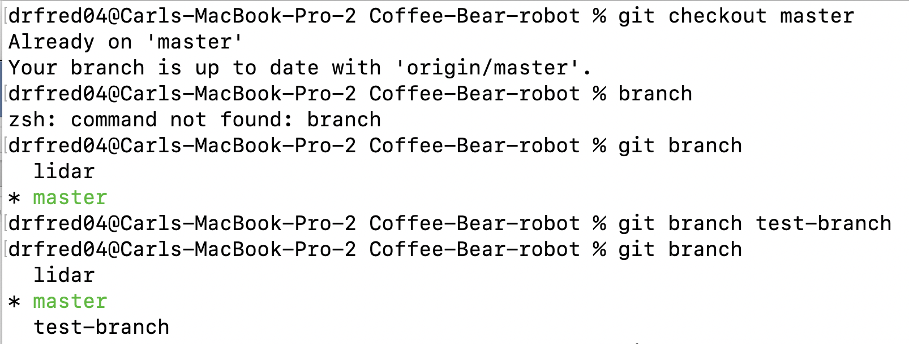

b)

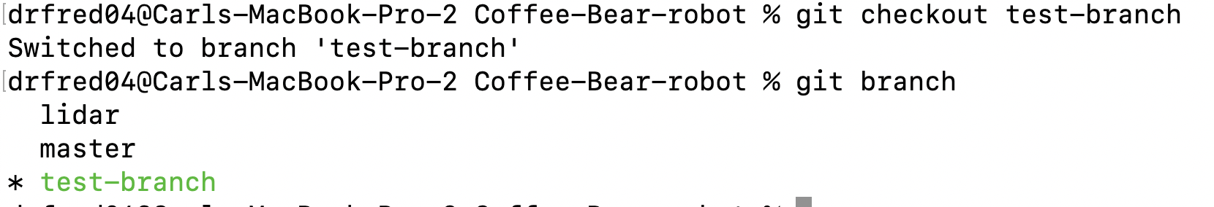

c)

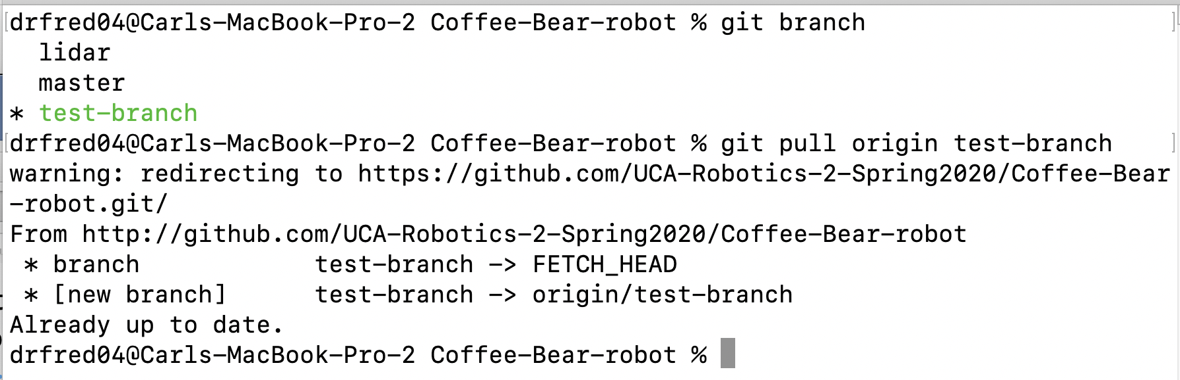

d)

e)

f)

g)

1. Wor